Rail Safety Week is back for 2023!

Rail Safety Week is back for 2023!

Rail Safety Week is back for 2023!

Rail Safety Week is back for 2023!

Rail Safety Week is back for 2023!

Rail Safety Week is back for 2023!

Rail Safety Week is back for 2023!

Rail Safety Week is back for 2023!

Rail Safety Week is back for 2023!
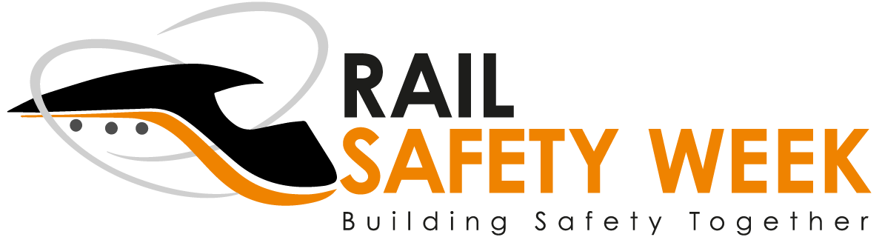

We are supporting Rail Safety Week!
From 26th June - 2nd July

Activities:
- Activity 1
- Activity 2
- Activity 3
- Activity 4

